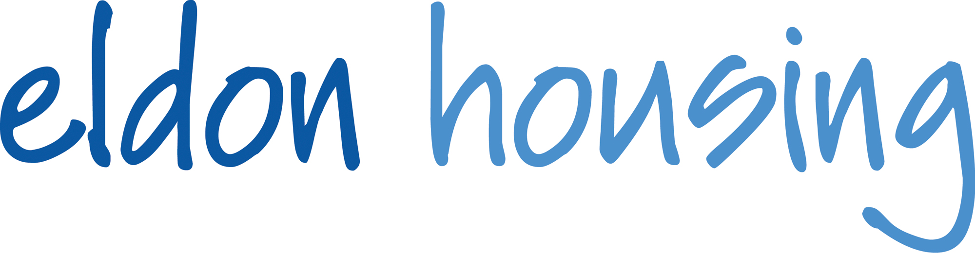
Job Description

Job Title: Helpdesk Administrator
Responsible to: Facilities Manager

Overall purpose of the job:
- To provide administrative support to the Facilities Management Team
- To provide a professional customer focused Help Desk service for the Association
- To provide administrative support to the business
- To ensure Facilities Management Staff and Contractors have the necessary information required to carry out the relevant works within the required timescales
- Contribute to providing a professional and caring Facilities Management service

Key responsibilities:

Facilities Management Services
- To manage the Association’s Help Desk, recording , responding and monitoring all calls, emails and other forms of communication ensuring action is taken and key performance targets are met
- To produce works orders for contractors ensuring action is taken and key performance targets are met
- To obtain and administer quotes for maintenance works, furniture. fixtures and equipment replacements
- To order stock, equipment and materials
- To collate performance information from the Associations computer system and produce monthly, six monthly and annual contractual reports.
- To collate planned and planned preventative maintenance work form the Associations computer system and produce monthly, six monthly and annual contractual reports.
- To update and maintain Facilities Management Operational Procedures
- To maintain all Planned Preventative Maintenance records and ensure external contractors provide method statements and risk assessments for all works.
- To ensure all Facilities Management records including statutory, reactive maintenance, planned maintenance are kept up to date
- To ensure that all approved contractors have the required up to date insurances.
- To ensure that the Association computer software system is updated with changes to building fabric, furniture. fixtures and equipment
- To process invoices
- Manage helpdesk queries through to completion
- Provide service users and tenants with feedback and updates.
- Maintain long term relationships with our partners and contractors

General Administration
- To provide administrative services to the Facilities Management Team such as copy typing and filing
- To administer quarterly catering surveys
- To administer seasonal catering menus
- Organise the association Health and Safety Advisor scheme inspection visit dates and administer any actions that arise from the inspections.
- To administer service contract renewals and update service charge contract budget spreadsheet with any changes in costs.
- To administer health and safety records including accidents reports
- To produce posters, equipment guides for frontline staff
- To be the first point of call for incoming telephone calls
- To act as receptionist welcoming visitors to the offices
- To open and distribute the post on a daily basis
- To ensure outgoing mail is posted on a daily basis
- To open and distribute the internal mail on a fortnightly basis
- To maintain the Quality Assurance System records.

Other
- To order staff uniform and maintain records of uniform supplied.
- When required attend meetings to take notes
- Periodically visit the schemes with the Facilities Manager and administer inspection reports.
- To ensure that the Association vehicles are booked in for their annual MOT and service.
- Undertake other duties as required by the Senior Management Team

Learning and Development
- To actively participate in self development as appropriate and training as identified for the benefit of performance management

Best Practice
- To work to promote the Association and ensure that it’s reputation is enhanced and to actively promote its Equal Opportunities and Diversity policies, ensuring that all practices/procedures are in accordance with best practice equality and diversity procedures
- To work within the Association's Equality and Diversity Policy and ensure implementation of the same
- Be aware of Health and Safety regulations at all times, ensuring compliance
- To adhere to the Association’s Environmental Policy

Person specification:

Essential Skills and Experience
- Good IT skills, including Microsoft Office
- Excellent verbal and written communication skills
- Experience of working within a service industry
- Experience of working in a busy, multi functional office
- Keen attention to detail, methodical work practice, organised reliable and motivated
- Supportive of a charitable organisation’s aims and values

- Proven experience in a similar customer focused business
- Computer Aided Facilities Management software experience
- Financial awareness

Competencies
The Help Desk Administrator is expected to demonstrate a high level of proficiency in these areas:
- Understands customer needs and strives to exceed these and provide a caring, customer focused service
- Works openly and honestly with colleagues, customers and suppliers and treats others with respect
- Is a confident and persuasive communicator, able to engage effectively with a range of audiences to create clarity and understanding
- Is committed to achieve results personally and through others; sets clear objectives and works with determination and energy
- Takes all opportunities to learn and develop and supports others to do the same
- Is open minded, flexible and responds positively to change; focuses on improvements
- Manages time, resources and priorities effectively and flexibly

